Assembly Language

📌 Definition:
# Source: AI Source: Provided by: [Data Path: Persons Table -> ID Column: 1, Name_En Column: Motasem Essam] -> From: [Chatgpt (GPT‑5 Mini)] on [12/9/2025]
Assembly language is a low-level programming language that uses human-readable symbols (mnemonics) instead of binary, but still stays very close to machine language.

🧠 Simple idea:
# Source: AI Source: Provided by: [Data Path: Persons Table -> ID Column: 1, Name_En Column: Motasem Essam] -> From: [Chatgpt (GPT‑5 Mini)] on [12/9/2025]
Assembly Language = Easier-to-read version of machine language

🔍 Characteristics:
# Source: AI Source: Provided by: [Data Path: Persons Table -> ID Column: 1, Name_En Column: Motasem Essam] -> From: [Chatgpt (GPT‑5 Mini)] on [12/9/2025]
- ✅ Uses short words (mnemonics) like MOV, ADD, SUB
- ✅ Closely related to machine code
- ✅ Requires an assembler to convert into machine language
- ❌ Harder than high-level languages
- ❌ Depends on the CPU architecture (not portable)

🧩 Example:
# Source: AI Source: Provided by: [Data Path: Persons Table -> ID Column: 1, Name_En Column: Motasem Essam] -> From: [Chatgpt (GPT‑5 Mini)] on [12/9/2025]
Assembly:
MOV A, 5
ADD A, 3
👉 This means:
- Put 5 into register A
- Add 3 to it

🔧Assembler

⚙️ What is an Assembler
# Source: AI Source: Provided by: [Data Path: Persons Table -> ID Column: 1, Name_En Column: Motasem Essam] -> From: [Chatgpt (GPT‑5 Mini)] on [12/9/2025]
An assembler is a translator program that converts Assembly Language (human-readable code) into Machine Language (binary code that the computer can execute).

📌 Simple definition:
# Source: AI Source: Provided by: [Data Path: Persons Table -> ID Column: 1, Name_En Column: Motasem Essam] -> From: [Chatgpt (GPT‑5 Mini)] on [12/9/2025]
Assembler = A program that converts assembly code into machine code

🧠 Simple idea:
# Source: AI Source: Provided by: [Data Path: Persons Table -> ID Column: 1, Name_En Column: Motasem Essam] -> From: [Chatgpt (GPT‑5 Mini)] on [12/9/2025]
You write:
MOV A, 5
The assembler converts it into:
10110000 00000101

🔍 How it works:
# Source: AI Source: Provided by: [Data Path: Persons Table -> ID Column: 1, Name_En Column: Motasem Essam] -> From: [Chatgpt (GPT‑5 Mini)] on [12/9/2025]
- You write assembly code
- The assembler reads it line by line
- It converts each instruction into binary machine code
- The computer executes the output

🧩 Key features:
# Source: AI Source: Provided by: [Data Path: Persons Table -> ID Column: 1, Name_En Column: Motasem Essam] -> From: [Chatgpt (GPT‑5 Mini)] on [12/9/2025]
- ✅ Translates assembly → machine language
- ✅ Works very fast
- ✅ Generates low-level, efficient code
- ❌ Specific to each CPU architecture

🆚 Assembler vs Compiler vs Interpreter
# Source: AI Source: Provided by: [Data Path: Persons Table -> ID Column: 1, Name_En Column: Motasem Essam] -> From: [Chatgpt (GPT‑5 Mini)] on [12/9/2025]
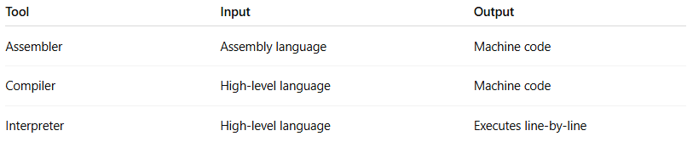
Tool | Input | Output
Assembler | Assembly language | Machine code
Compiler | High-level language | Machine code
Interpreter | High-level language | Executes line-by-line

⚙️ Example:
# Source: AI Source: Provided by: [Data Path: Persons Table -> ID Column: 1, Name_En Column: Motasem Essam] -> From: [Chatgpt (GPT‑5 Mini)] on [12/9/2025]
Assembly code:
MOV A, 5
ADD A, 3
Assembler output:
Binary instructions (machine code)

✅ Summary:
# Source: AI Source: Provided by: [Data Path: Persons Table -> ID Column: 1, Name_En Column: Motasem Essam] -> From: [Chatgpt (GPT‑5 Mini)] on [12/9/2025]
The assembler is the bridge between assembly language and the computer—it turns readable instructions into binary that the CPU can execute.

⚙️ How it works:
# Source: AI Source: Provided by: [Data Path: Persons Table -> ID Column: 1, Name_En Column: Motasem Essam] -> From: [Chatgpt (GPT‑5 Mini)] on [12/9/2025]
- You write assembly code
- The assembler converts it to machine code
- CPU executes the machine code

🆚 Assembly vs Machine vs High-Level
# Source: AI Source: Provided by: [Data Path: Persons Table -> ID Column: 1, Name_En Column: Motasem Essam] -> From: [Chatgpt (GPT‑5 Mini)] on [12/9/2025]
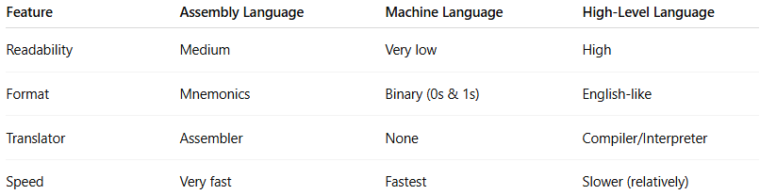
Feature | Assembly Language | Machine Language | High-Level Language
Readability | Medium | Very low | High
Format | Mnemonics | Binary (0s & 1s) | English-like
Translator | Assembler | None | Compiler/Interpreter
Speed | Very fast | Fastest | Slower (relatively)

🎯 Where it is used:
# Source: AI Source: Provided by: [Data Path: Persons Table -> ID Column: 1, Name_En Column: Motasem Essam] -> From: [Chatgpt (GPT‑5 Mini)] on [12/9/2025]
- Operating systems 🖥️
- Embedded systems 🔌
- Device drivers
- Performance-critical code 🚀

✅ Summary:
# Source: AI Source: Provided by: [Data Path: Persons Table -> ID Column: 1, Name_En Column: Motasem Essam] -> From: [Chatgpt (GPT‑5 Mini)] on [12/9/2025]
Assembly language gives programmers more control over hardware than high-level languages, but it is harder to write and understand.

